**How to embed Power Automate in Dynamics 365 for Finance and Supply Chain**

Model-driven app design is a component-focused approach to app development for Dynamics 365. In this topic, you simplify how to create an App for Finance and Supply chain solution

**Step 1: Adding Finance application in our environment**

1. Go To <https://trials.dynamics.com/> (we are using trial module for our session)

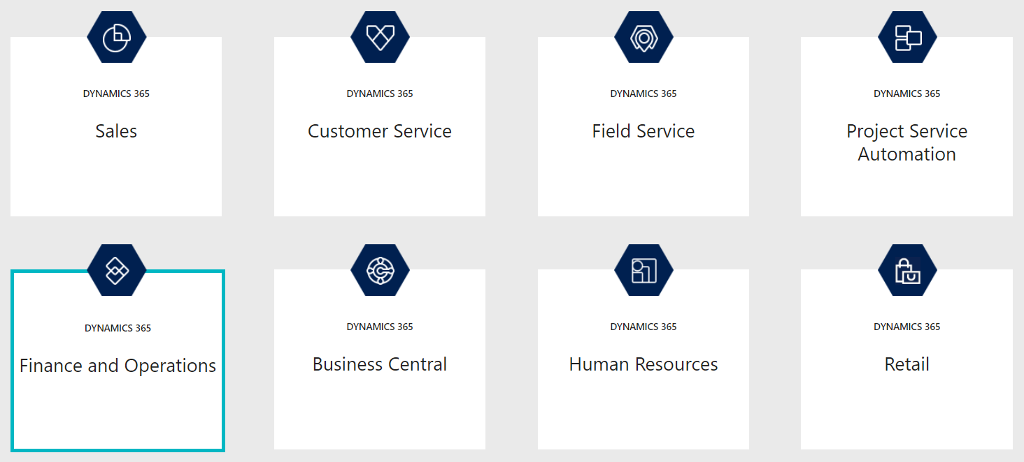

1. Select Finance and Operations
2. Enter Work Email, i.e. same email we created for office 365 developer subscription
3. Enter 10-digit Phone number

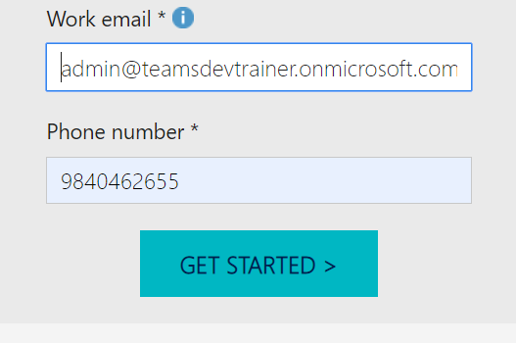

1. Click Get Started button, it will redirect to new window

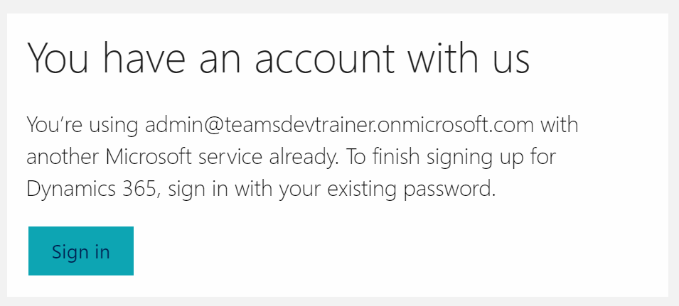

1. Sign In and continue
2. It will open the dynamics 365 Finance and Operations Business Application dashboard

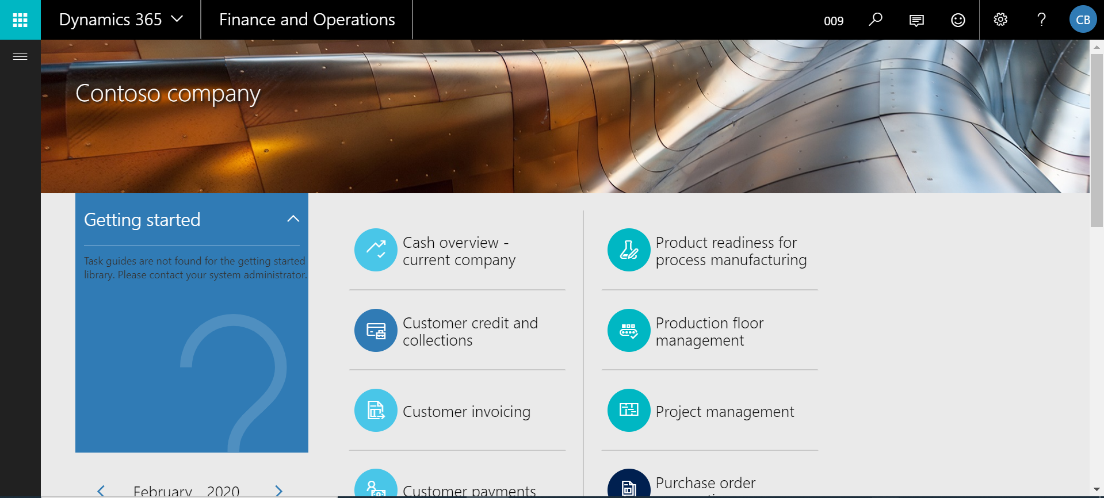

**Step 2: Business events and Microsoft Power Automate**

This topic shows how to perform the following tasks:

* Create a new flow in Power Automate.
* Trigger a business event.

## Create a new flow in Power Automate

1. Sign into Power Automate portal.
2. Select an existing environment where you have the permissions needed to create a Power Automate resource. The default environment is open to all companies.
3. Select **New > Create from blank**.
4. Search for **Dynamics 365 for Finance and Operations** and select the connector.
5. You will notice a trigger named **When a Business Event occurs**. Select this trigger.
6. Select your environment instance, category, event name, and legal entity.